michaelsbagley
- Smells Like Wet Sheep
- 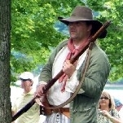
- Moderator

- 2,548 posts
- Gender:Male
- Location:Columbus, Ohio
- Interests:Mostly into GAoP, but starting to develop more Buccaneer era stuff for re-enacting as well. Generally I do re-enact both piratical/nautical and other impressions from the period. I am focusing on more "common" impressions from the period (i.e. average sailor/pirate, rank and file Red Coat, early Colonial huntsman, etc.)
(IP: 69.219.80.75) ·
Posted January 13, 2008 · Report post
My girlfriend has been asking me about what types of things a lady of the period would have, and well to be honest, I haven't the slightest clue as to the material culture items that women would possess. Does anyone have any ideas? Or images they can share the links to or post here?
I think she is thinking mostly personal items such as combs, brushes, other grooming items, popular knick knacks of the time (if any), any items a woman might pack while travelling, things she might keep at home. I know this is kind of vague, but I am really not sure how to answer.
Thanks in advacne for any help!!!

- Quote
- Edit

Captain Pogue
- Ship's Master
- Member

- 190 posts
- Location:Portland, Or
- Interests:All things Piratical.<br>Escaping Texas and moving up to the Northwest.<br>Making things.
(IP: 152.135.148.124) · ·
Posted January 14, 2008 · Report post
Michael,
I don't have much to offer, I'm working with my wife on her period clothes. I'd be interested in having some distinction on this subject between common women of the time and ladies. My wife doesn't want to be a wench
Pogue

- Quote
- Edit
- Options

Capt. Sterling
- Sticky Fingers Sterling Needs a New Hat
- Member

- 10,302 posts
- Gender:Pyrate Hunter
- Location:here
- Interests:Killing pirates, haven't met one yet worth keeping alive....
(IP: 76.1.135.215) · ·
Posted January 14, 2008 (edited) · Report post
Mask, fan , muff, handkerchief for a lady off the top of my head. Sewing or embroidery items, penner and stationary if she can read and write and has some means to obtaining such instruments. Ladies of quality are often shown with musical instruments or some sort of pet in many of the fashion plates...
Now mind you the following are more upper class...so it depends on your lady's choice...

note the walking stick
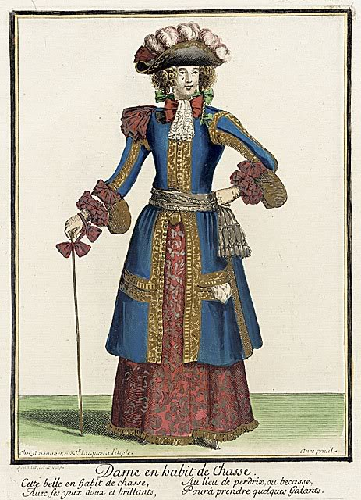

Also these plates are from the earlier GAoP...depending on where you set the opening date for the time frame
As to poorer, more working class, take a look at the Town Criers images, and select some sort of wares for her to sell....makes for great demos and she always has something to carry and do..
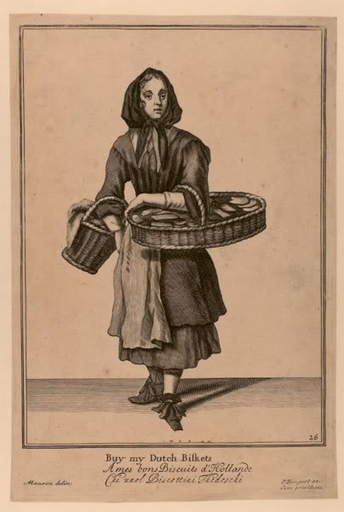
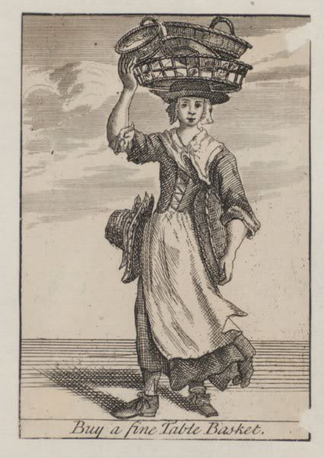

Again, the cut of a mantua does not change drastically from class to class, but the choice of fabrics does and the length of the train appears to often be shorter and more workable for the lower or working classes... remember also that second hand clothing is a big business, at least in England during the time.
Edited January 19, 2008 by Capt. Sterling

- Quote
- Edit
- Options

Capt. Sterling
- Sticky Fingers Sterling Needs a New Hat
- Member

- 10,302 posts
- Gender:Pyrate Hunter
- Location:here
- Interests:Killing pirates, haven't met one yet worth keeping alive....
(IP: 76.1.135.215) · ·
Posted January 14, 2008 (edited) · Report post
Some reading for the ladies as well... a bit of mind set/attitude
A Gentle Woman's Companion, or Guide to the Female Sex perhaps by Hanna Wooley 1675
The Ladies's Dressing Room Unlock'd...Mary EVelyn, 1690.
The Art of Charming 1697
A little something to get them started...
Edited January 14, 2008 by Capt. Sterling

- Quote
- Edit
- Options

michaelsbagley
- Smells Like Wet Sheep
- Moderator

- 2,548 posts
- Gender:Male
- Location:Columbus, Ohio
- Interests:Mostly into GAoP, but starting to develop more Buccaneer era stuff for re-enacting as well. Generally I do re-enact both piratical/nautical and other impressions from the period. I am focusing on more "common" impressions from the period (i.e. average sailor/pirate, rank and file Red Coat, early Colonial huntsman, etc.)
(IP: 69.219.80.75) · ·
Posted January 14, 2008 (edited) · Report post
Thank you very much Capt. Sterling... You have managed to both give me a great start with your post, and inadvertantly(?) address another issue that has been knawing at my mind... The issue of the term "wench" being applied to all women of the period who aren't upper class or fine ladies.
Capt. Pogue, please note the last three images... These are common women-folk, and NOT wenches. There are plenty of respectable (and good looking) impressions for a woman to do that aren't upper class, fine lady, or wench. I am getting the *vibe* that a lot of the women are resisting doing a more commoner impression for the period because they don't want to get labelled "wench". If the use of this term persists, we are going to have pirate re-enactments with tons of pirates, and a whole bunch of "ladies" with NO common women... Personally, I would love to see a lot fewer "ladies" and more common women (to dream the impossible dream And to be honest there are admittedly more and more common women impression being done by some of the ladies here, like Silkie and Cheeky)... And I have been gently coaxing my better half for months to get her comfortable with doing a more common women's impression. It's taken a LOT of work, but I am starting to feel like I am in the home stretch, I just don't want her to get labelled wench her first time out and have her suddenly reconsider dressing as anything but a lady.
Please understand I am not angry or pissed or anything, I am just concerned about the VERY "rennie" term of "wench" being dragged into the re-enactment side of things where it is both innappropriate, and potentially harmful to the cause...
Thanks again for your response Sterling!
Can't wait to see how your other halfs garb turns out Capt. Pogue!
Edited January 14, 2008 by michaelsbagley

- Quote
- Edit
- Options

Capt. Sterling
- Sticky Fingers Sterling Needs a New Hat
- Member

- 10,302 posts
- Gender:Pyrate Hunter
- Location:here
- Interests:Killing pirates, haven't met one yet worth keeping alive....
(IP: 76.1.135.215) · ·
Posted January 14, 2008 (edited) · Report post
Don't know if this helps...but wench can mean a number of things...
Online Etymology Dictionary -
wench
c.1290 wenche "girl or young woman," shortened from wenchel "child" (12c.), from O.E. wencel, probably related to wancol "unsteady, fickle, weak," and cognate with O.N. vakr "child, weak person," O.H.G. wanchal "fickle." The word degenerated through being used in ref. to servant girls, and by 1362 was being used in a sense of "woman of loose morals, mistress." The verb meaning "to associate with common women" is from 1599.
Perhaps if more study of the word was done, then the gents would start to apply it more appropriately....as I see more men constantly using the term than women...
As to Ladies... we allow those in our crewe that wish to ascend to such lofty heights to take turns at events, thus Cheeky plays the Actress/Mistress at some events and Bess the Indentured Servant at others... Bess is a hoot... and she works her tail off cooking, cleaning, feeding and doing exactly what she is told to do. Mad Mary portrays the widow of a wealthy merchant looking to trade with pirates when they come into port. The rest of the ladies in our crew opt for the more common impression and usually all of them only dress up in their best gowns for the balls we attend... personally, I have yet to attend a ball where any one stays in character so if this give the ladies a chance to get all decked out and have fun in their finery by all means I am for it then...
Edited January 14, 2008 by Capt. Sterling

- Quote
- Edit
- Options

Captain Pogue
- Ship's Master
- Member

- 190 posts
- Location:Portland, Or
- Interests:All things Piratical.<br>Escaping Texas and moving up to the Northwest.<br>Making things.
(IP: 152.135.148.124) · ·
Posted January 14, 2008 · Report post
Generally speaking you should never generalize and that's what I was doing. I think I tend toward the term wench because of something Cpt. Sterling pointed out about occupations. You've probably seen this too Michael with your gf. What woman wants to be a hat seller, or sell flowers while their significant other gets to be a pirate?
I'd still use wench, despite your objections Michael, but only so far as to categorize a generic woman. And one that would associate with pirates, not necessarily a lower-class upstanding woman. I'll make sure to not throw the word around too loosely in the pub though, I understand some of the issues when dealing with an so regarding historically accurate issues like this.
I think women that don't want to dress like a man kinda get the short end of the stick when it comes to what they can dress like. Piracy, along with the rest of the world, was so male dominated that we have to break from historical accuracy at some point to be able to include the women in our lives it seems. Especially, in some fashion that they would truly enjoy.
My wife is going for a riding habit. I keep telling her to get a fowler. That seems to be the most likely weapon a lady wearing a riding habit would have. Did ladies go hunting back then, and do more than hang out while the boys went shooting at things? Are there any good images of ladies hunting and what stuff they might have?
No worries,
Pogue

- Quote
- Edit
- Options

Capt. Sterling
- Sticky Fingers Sterling Needs a New Hat
- Member

- 10,302 posts
- Gender:Pyrate Hunter
- Location:here
- Interests:Killing pirates, haven't met one yet worth keeping alive....
(IP: 76.1.135.215) · ·
Posted January 14, 2008 (edited) · Report post
Captain Pogue said:
What woman wants to be a hat seller, or sell flowers while their significant other gets to be a pirate?
Actually that would cover all of the women in my crewe... in port ladies who work hard for their livelihoods. Skittles when not portraying the officers' laundress and semptstress is wanting to sell milk, Cheeky sells bread and beer, Lynette sell trinkets for the ladies, Silkie is wanting to run an ordinary, we have a tavern for her where she and Rats, when he isn't knife fighting with Maddogge or running around playing bosun can serve up all kinds of mischief... just to name a few.
There are quiet a number of roles that women can portray at "in port" events... and these roles can be a lot of fun to carry out, and frankly they can be rather independent with these roles as well, they don't need a gent to see them around. Honestly I haven't heard any of the girls complaining about the guys being sailors/privateers/pirates/pyrate hunters and them "only being" hawkers... everyone wants to nibble on Cheeky's buns, what's not to enjoy?
Edited January 14, 2008 by Capt. Sterling

- Quote
- Edit
- Options

Capt. Sterling
- Sticky Fingers Sterling Needs a New Hat
- Member

- 10,302 posts
- Gender:Pyrate Hunter
- Location:here
- Interests:Killing pirates, haven't met one yet worth keeping alive....
(IP: 76.1.135.215) · ·
Posted January 14, 2008 (edited) · Report post
These are taken from originals but are not so themselves

And not to be argumentative... just want us all to get thinking about it, depending on the location and event, would a lady be walking around with a fowling piece?
Edited January 14, 2008 by Capt. Sterling

- Quote
- Edit
- Options

Captain Pogue
- Ship's Master
- Member

- 190 posts
- Location:Portland, Or
- Interests:All things Piratical.<br>Escaping Texas and moving up to the Northwest.<br>Making things.
(IP: 152.135.148.124) · ·
Posted January 14, 2008 · Report post
A Lady has to protect herself when she's amongst pirates and all that.
mmm, buns! Are they hot?

- Quote
- Edit
- Options

Capt. Sterling
- Sticky Fingers Sterling Needs a New Hat
- Member

- 10,302 posts
- Gender:Pyrate Hunter
- Location:here
- Interests:Killing pirates, haven't met one yet worth keeping alive....
(IP: 76.1.135.215) · ·
Posted January 14, 2008 · Report post
Have her ditch the gun...(yeah we all know you want her to have one so you can play with it... ) and get her a servant, some trunks and allow her to walk about claiming she has booked passage on one of the ships traveling to Port Royal to visit relatives on one of the plantations.

- Quote
- Edit
- Options

Capt. Sterling
- Sticky Fingers Sterling Needs a New Hat
- Member

- 10,302 posts
- Gender:Pyrate Hunter
- Location:here
- Interests:Killing pirates, haven't met one yet worth keeping alive....
(IP: 76.1.135.215) · ·
Posted January 14, 2008 (edited) · Report post
Captain Pogue said:
mmm, buns! Are they hot?
Extremely... and being captain, I am the only one that actually gets to nibble!!
at least when they aren't green and moldy...
Edited January 14, 2008 by Capt. Sterling

- Quote
- Edit
- Options

Captain Pogue
- Ship's Master
- Member

- 190 posts
- Location:Portland, Or
- Interests:All things Piratical.<br>Escaping Texas and moving up to the Northwest.<br>Making things.
(IP: 152.135.148.124) · ·
Posted January 14, 2008 · Report post
Pretty obvious about the gun, huh???
I was thinking a servant would be good... adoption is a bit pricey though...

- Quote
- Edit
- Options

Capt. Sterling
- Sticky Fingers Sterling Needs a New Hat
- Member

- 10,302 posts
- Gender:Pyrate Hunter
- Location:here
- Interests:Killing pirates, haven't met one yet worth keeping alive....
(IP: 76.1.135.215) · ·
Posted January 14, 2008 · Report post
Ah her servants gone and run off on her? What's a lady to do with her belongings? After all there might be pirates around, and other unsavory sorts... surely she can depend on the kindness of a big, strapping gent such as yerself... she can toss ye a coin or two for yer troubles of assisting her...and if ye play yer cards right... who knows what else she might be giving ye....

- Quote
- Edit
- Options

withoutaname
- Ship's Master
- Member

- 118 posts
- Location:brooklyn, ny
- Interests:new to pyrate re-enacting, but been (passively) involved in 1500-1600 faires for awhile, along with a high level of interest in history (with a flair for the love of the arts and feminist impact through out time in the roles of courtesans and performance..blahh blahh blahh) I develop training content and materials and actually love what I do but would give it up to escape to a tropical island own a B&B, teach yoga in the morning and run a small ex-pat pub on the first floor at night... dreams shall be taken advantage of when I can amount enough treasure to do them right. In the mean time to satisfy the love of the warm breeze and the clear water I travel with my pyrate as much as possible in search of an island we hope to call home someday.<br><br>New blog (there's nothing there yet!) http://almostescaped.blogspot.com/
(IP: 64.25.16.100) · ·
Posted January 14, 2008 · Report post
michaelsbagley said:
My girlfriend has been asking me about what types of things a lady of the period would have, and well to be honest, I haven't the slightest clue as to the material culture items that women would possess. Does anyone have any ideas? Or images they can share the links to or post here?
I think she is thinking mostly personal items such as combs, brushes, other grooming items, popular knick knacks of the time (if any), any items a woman might pack while travelling, things she might keep at home. I know this is kind of vague, but I am really not sure how to answer.
Thanks in advacne for any help!!!
thank you for starting this thread. As I like being myself with a flair of fantasy , this is part of what I am working on myself so when I need to be more historically accurate historically accurate, I can be. So feedback is valued, and I thought this was a good place to talk about this since Michael's lady is also working through some of the same aspects.
I am going for a common lady who ran away with the likes of a scoundrel (ahh love and how true to life...) but came from a merchant class family (father business man, trade of wine, and musical instruments) and a mother who was a mid-wife and healer as her mother before her. I have convinced myself aside from having a tendency to dress a little above my class from my upbringing and a base knowledge of medicinals from that time period I am able to adapt myself into this role, rather then a role I am not interested in as myself. Plus I can busy myself whenever with herbal lore and educating others about their ailments. Thea character background I am building gives me ability to have a few nice things that came with me such as my comb, small mirror, a few fine needles, some jewelry, plus an explaination of how I met someone outside of my class, managed to run away etc. The hardest part I am having is finding a suitable name. certain aspects we have figured out like last name, that is easy :) But first name is giving me challenges still...
I am not lettin the men have all the fun on this one :)

- Quote
- Edit
- Options

michaelsbagley
- Smells Like Wet Sheep
- Moderator

- 2,548 posts
- Gender:Male
- Location:Columbus, Ohio
- Interests:Mostly into GAoP, but starting to develop more Buccaneer era stuff for re-enacting as well. Generally I do re-enact both piratical/nautical and other impressions from the period. I am focusing on more "common" impressions from the period (i.e. average sailor/pirate, rank and file Red Coat, early Colonial huntsman, etc.)
(IP: 69.219.80.75) · ·
Posted January 14, 2008 (edited) · Report post
Captain Pogue said:
Generally speaking you should never generalize and that's what I was doing. I think I tend toward the term wench because of something Cpt. Sterling pointed out about occupations. You've probably seen this too Michael with your gf. What woman wants to be a hat seller, or sell flowers while their significant other gets to be a pirate?
Actually, my other half loves period writing instrument, and is leaning towards being a clerk or secretary or something of that sort... Possibly a merchant's assistant running an erand on behalf of the merchant who doesn't want to deal directly with such unsavory folks as pirates, or perhaps, the a secretary acting on behalf of a smuggler too chicken to deal directly with pirates... Who knows... She'll work it out in her own time...
Captain Pogue said:
I'd still use wench, despite your objections Michael, but only so far as to categorize a generic woman. And one that would associate with pirates, not necessarily a lower-class upstanding woman. I'll make sure to not throw the word around too loosely in the pub though, I understand some of the issues when dealing with an so regarding historically accurate issues like this.
Please do use the term however much and in whatever context you feel appropriate... I was more raising the point to draw attention to the variety of common impressions possible for a women ro portray... I wasn't trying to single you out or thumb my nose at you.
Captain Pogue said:
My wife is going for a riding habit. I keep telling her to get a fowler. That seems to be the most likely weapon a lady wearing a riding habit would have. Did ladies go hunting back then, and do more than hang out while the boys went shooting at things? Are there any good images of ladies hunting and what stuff they might have?
Captain Sterling said:
And not to be argumentative... just want us all to get thinking about it, depending on the location and event, would a lady be walking around with a fowling piece?
With a riding habit and a fowler (I tried talking Jessica into this, but she doesn't like guns particularly long arms), she could portray a lady out on a hunting or something like that who has come across the pirates and is curious, or is trying to strike a deal or any number of scenarios (although she would likely have attendants or company of some sort, but not neccessarily). It might not work in all scenarios (specially a port scenario), but for say a careening camp, it might not be that much of a stretch...
Edited January 14, 2008 by michaelsbagley

- Quote
- Edit
- Options

Capt. Sterling
- Sticky Fingers Sterling Needs a New Hat
- Member

- 10,302 posts
- Gender:Pyrate Hunter
- Location:here
- Interests:Killing pirates, haven't met one yet worth keeping alive....
(IP: 76.1.135.215) · ·
Posted January 14, 2008 · Report post
withoutaname said:
I am not lettin the men have all the fun on this one :)
Oh my dear, I am certain the ladies will chime in, in due time...

- Quote
- Edit
- Options

Cheeky Actress
- Contesse de Tosspot
- Member

- 3,876 posts
- Gender:Female
- Location:Middlesort Port of the Midwest
- Interests:Seeking all who have been Forsaken in their quest.
(IP: 141.129.1.98) · ·
Posted January 14, 2008 (edited) · Report post
Capt. Sterling said:
Now mind you the following are more upper class...so it depends on your lady's choice...

Oooh, Pretty this one is! This plate has me written all over it, Captain! I love the details of extras in it....the servant and the Vizzar!
And yes, MadMary...no bunny ears!
Edited January 14, 2008 by Cheeky Actress

- Quote
- Edit
- Options

Capt. Sterling
- Sticky Fingers Sterling Needs a New Hat
- Member

- 10,302 posts
- Gender:Pyrate Hunter
- Location:here
- Interests:Killing pirates, haven't met one yet worth keeping alive....
(IP: 76.1.135.215) · ·
Posted January 14, 2008 · Report post
Cheeky Actress said:
And yes, MadMary...no bunny ears!
Thank God!

- Quote
- Edit
- Options

Cheeky Actress
- Contesse de Tosspot
- Member

- 3,876 posts
- Gender:Female
- Location:Middlesort Port of the Midwest
- Interests:Seeking all who have been Forsaken in their quest.
(IP: 141.129.1.98) · ·
Posted January 14, 2008 · Report post
Beign part of the 'middlesort' land lubbers... I must admit that Captain Sterling is correct when he mentions that their are a lot of 'parts' for a woman to play.
I have three personas thus far...Actress, Hawker/Cryer, and Diver. I have yet had the chance to bring forth the Diver (pick-pocket) but I am sure she'll do just fine with the Pyrates!
Just let the ladies in your crew know that they do have tons of choices!

- Quote
- Edit
- Options

Mary Diamond
- It's My Fault
- Moderator

- 1,050 posts
- Gender:Female
- Location:Illinois
- Interests:Things I Love: Horticulture, Travel, Volleyball, Reading, Sewing, Costuming, Halloween, esp. props!, Halo, Halo2, Halo3, ODST, and, of course, Pyracy.
(IP: 67.167.49.211) · ·
Posted January 14, 2008 · Report post
Indeed!
Lovely images, Captain, and thank you so much for the helpful insights as we all continue to develop our character. I daresay it is as helpful for the gents to read this as the ladies ~ the better to understand us by.

- Quote
- Edit
- Options

Captain Pogue
- Ship's Master
- Member

- 190 posts
- Location:Portland, Or
- Interests:All things Piratical.<br>Escaping Texas and moving up to the Northwest.<br>Making things.
(IP: 66.68.185.229) · ·
Posted January 14, 2008 · Report post
Capt. Sterling, your link for "The Art of Charming 1697" seems to be a bit off...

- Quote
- Edit
- Options

Capt. Sterling
- Sticky Fingers Sterling Needs a New Hat
- Member

- 10,302 posts
- Gender:Pyrate Hunter
- Location:here
- Interests:Killing pirates, haven't met one yet worth keeping alive....
(IP: 76.1.135.215) · ·
Posted January 14, 2008 (edited) · Report post
Aye Capt. Pogue, right ye are... by seven years at least...not to mention being the entirely wrong link so much for not having one's spectacles near to hand first thing in the morning...
lets try this instead
my apologies
Edited January 14, 2008 by Capt. Sterling

- Quote
- Edit
- Options

Kate_Souris
- Texting on a Stolen Bike
- Member

- 545 posts
- Gender:Female
- Location:Ohio
(IP: 69.219.80.75) · ·
Posted January 14, 2008 · Report post
I suppose that, in needing to know the answer to a rather difficult question, I should have perhaps posed it myself instead of sending Michael in to do my dirty work. Though my other half (note that I did not say 'better' ) wrote what I asked, that was not necessarily what was in my little brain.
Having previously done viking re-enactment, we had all of the little details and accessories down to a 't', as it were. Combs, toiletries, utensils, crafting, etc.
I did read through everything that Sterling posted (which...you nearly need an entirely separate language to interpret), I am still at a bit of a loss in regards to the general 'stuff' that a lady might have. I like accessories...more than the garb in most regards because I feel that the accessories are what actually makes it. Does that make any sort of sense? Like I wonder if a silver handled mirror would be appropriate? Or a silver comb with ivory teeth? Small crystal jars with powders and scented waters?
I am gathering an understanding in regards to the period writing utensils, thanks to the Whydah exhibit and Michael's insistence on dragging us down there twice. The second time around, I noticed the brass dip pen, lead inkwell, and brass seals. And thankfully, I have a certain pirate making me a portable lapdesk that will keep everything contained nicely once I gather the needed supplies.
Though I will keep looking and reading, if anyone has some artful direction that they can provide, that would be fantastic. Anything helps and everything is definately considered.
Was I clearer, Michael?

- Quote
- Edit
- Options

Captain Pogue
- Ship's Master
- Member

- 190 posts
- Location:Portland, Or
- Interests:All things Piratical.<br>Escaping Texas and moving up to the Northwest.<br>Making things.
(IP: 66.68.185.229) · ·
Posted January 14, 2008 · Report post
Actually, I am confused. You've got the accessories for ladies down, are you looking for more input as to what a woman of your station would have?
I whole heartedly agree about about accessories making the outfit :angry:
My wife thought this might be link might be useful.
1700s Rococo
Oh, and welcome,
Pogue

LadyBarbossa
- Wealth Redistributor & Mischief Making
- Moderator

- 4,641 posts
- Gender:Female
- Location:The Land Between Two Rivers, aka Iowa
- Interests:18th c Piracy to American Revolution, Victorian Thespians, Equitation, tigers, Friesians, cooking, playing my viola & music in general. Researcher of Major General Baron Johann de Kalb. LOVES the Phantom of the Opera (who's also Brethren)! Transformers, Stargate, Star Trek, Star Wars, NCIS, Bones, The X Files
(IP: 205.188.116.16) · ·
Posted January 15, 2008 · Report post
michaelsbagley said:
I am getting the *vibe* that a lot of the women are resisting doing a more commoner impression for the period because they don't want to get labelled "wench". If the use of this term persists, we are going to have pirate re-enactments with tons of pirates, and a whole bunch of "ladies" with NO common women... Personally, I would love to see a lot fewer "ladies" and more common women (to dream the impossible dream :angry:
well, m'dear.... depends upon what you define as Commoner and Lady. Gentlewoman doesn't always classify as a Lady.
I know with my Rev War impression... she's a Gentlewoman (poor at French unfortunately) of the middle class. She's no wench or poor servant lass, or whatever you want to call them. But she's no Lady, either.
It's all about the research, finding something that trips the trigger... won't come right away and will be lots of trial and errors and trying different personas until that right one comes along. Research is what keeps me in line of understanding a Gentlewoman from Charleston during the Rev War.
I can also apply this persona to the time of Blackbeard, too. learning the mannerisms, appearance and more of a Gentlewoman of that specific timeperiod as the attire and appearance was rather different in the early 1700s than the later 1700s.
Just depends upon where she is from and her locale, what would be available to her, etc.
Sterling has some good information there.
Hehehehe... Cheeky... I agree... that mantua with the gold petticoat is gorgeous! New gown to make next? :angry:
~Lady B
:angry:

- Quote
- Edit
- Options

Ransom
- It's Going on Your Permanent Record
- Moderator

- 5,177 posts
- Gender:Female
- Location:The pirate wasteland of Southern OR.
- Interests:I belong to the Barn Owls Writers Group. My husband and I live on 20 acres with four cats, and a two horses, Delight and Apollo — used to have longhorn cattle, sheep, but no more. Our 28' Tollycraft is moored in Charleston harbor. She has no sails, but dreams of being a schooner.
I like to ride my horse doing Medieval gaming, and now mounted archery, and trail course challenges. I also garden, read, do artwork, write, make beaded jewelry for my Website "Found in the Ruins", and go on antique/junk crawls with my husband of 20+ years. I am somewhat of a costume making junkie. Now I make pyrate and steampunk costumes, as well as SCA costumes and horse bardings, and am having WAY too much fun....
(IP: 69.59.202.245) · ·
Posted January 15, 2008 · Report post
Having done SCA costuming for ten plus years, I agree with Lady B. A persona evolves over time. You may start out with one thing, and a year or so down the road decide that's really wrong for what you want to do. That's why, even though I'm just starting in the GAoP era, I'm not sweating the garb issue too much. I know things will change and develop. Who knows, I may even make a dress one day! LOL
Sterling is a font of information, so drink deeply.
And gentlewoman meant basically middle class, I believe. Not highclass noblewoman, not lower class poor, but much as most of us in real life are right now, middle class. This woman would find it insulting to be referred to as a 'wench' (and her papa would come looking for you!).
And oh yes, I can definately see Cheeky in that costume. But who is she going to get to hold the train of her dress?

- Quote
- Edit
- Options

Capt. Sterling
- Sticky Fingers Sterling Needs a New Hat
- Member

- 10,302 posts
- Gender:Pyrate Hunter
- Location:here
- Interests:Killing pirates, haven't met one yet worth keeping alive....
(IP: 76.1.135.215) · ·
Posted January 15, 2008 (edited) · Report post
Ransom said:
And oh yes, I can definately see Cheeky in that costume. But who is she going to get to hold the train of her dress?
One of the snotties no doubt...
Um... I understand that desire for all the little details regarding one's kit... for instance the oddball things I carry in my pocket or the lense I wear about my neck that are all pc and which work in unison for my particular character.
How many "little items" are you looking for and how are you going to explain carrying them all about on your person during an event? I mean why would you have jars of powders and scents with you? I am not asking this to be annoying, but it does make a difference regarding your character and the actual event you are attending...
For instance.... If I am in port, say for a refit of my ship. I plan to stay for a month or two... then I may take more of my individual possessions off of the ship for my stay in town. Now, if I am at an event where my crew has landed for a short spell to collect fresh water... I would bring the bare essentials really... weapons, and the clothes on my back... I wouldn't need to bring a large amount of personal things ashore..so why bring them to an event? If we are at an event like RF4, we set up a display and bring just about everything we currently have to demonstrate life on board a ship... such as traverse boards, ship's bell, and hour glass, log books, charts, navigational tools, all the weapons, spices, cargo, letters of Marque etc...etc...etc...
I think getting all the little pieces together, unless this is just a personal passion (in which case, by all means collect away... I certainly have more sh-stuff for my character than I will ever actually need at any one event) really depends on what you wish to portray and how it will fit in...just my two cents... if you could tell us more about your character we could help you focus your direction more.
And I bet this didn't make one bloody hell of a bit of sense... sorry migraine today..
Edited January 15, 2008 by Capt. Sterling

- Quote
- Edit
- Options

michaelsbagley
- Smells Like Wet Sheep
- Moderator

- 2,548 posts
- Gender:Male
- Location:Columbus, Ohio
- Interests:Mostly into GAoP, but starting to develop more Buccaneer era stuff for re-enacting as well. Generally I do re-enact both piratical/nautical and other impressions from the period. I am focusing on more "common" impressions from the period (i.e. average sailor/pirate, rank and file Red Coat, early Colonial huntsman, etc.)
(IP: 69.219.80.75) · ·
Posted January 15, 2008 · Report post
Capt. Sterling said:
And I bet this didn't make one bloody hell of a bit of sense... sorry migraine today..
Sorry to hear you not feeling well... I've come down with a cold myself...
Not to speak for Jessica (again ), but I think she is wanting to collect any ofand all of those little things so we can, so we can have them on hand for whatever style of event we do... Whether it is a small living history display at a local school/faire/festival showing off as many period correct do-dads as we can (whether nautical or not), or whether it is camping at PiP for a week, and just trying to have period correct grooming devices or living history project type things to work on. Like I said earlier, Jessica (who posts here as Ilanah) is curious about writing implements (anything a scribe, clerk, secretary would reasonably have) and just general grooming instraments (brushes, combs, mirrors etc.) would probably be most of what she is interested in for now.
As for the commoner/lady discussion... I think that whole thing might deserve it's own thread... But I really think it boils down to a difference in re-enactment styles, and I would rather focus on the commonalities and means of combining different re-enactment styles than risk offending someone by pointing out differences.
Thanks again to everyone for their feedback and continued help.
Sterling, try and take it easy, I've never been a migraine person, but I lived with one, and have an idea of how much pain it can cause.

- Quote
- Edit
- Options

Capt. Sterling
- Sticky Fingers Sterling Needs a New Hat
- Member

- 10,302 posts
- Gender:Pyrate Hunter
- Location:here
- Interests:Killing pirates, haven't met one yet worth keeping alive....
(IP: 76.1.135.215) · ·
Posted January 15, 2008 (edited) · Report post
Hmmm I'm thinking, have her begin with a traveling trunk and start filling it with things she would take with her on a long journey... this would be something she could easily display and teach from...removing objects and explaining them... for instance...
Lady's casket...1650-80
a bit early but I have a later picture in black in white..some where... will hunt for it...
The following maybe a bit too impressive...grin...
Toiletry set
Edited January 15, 2008 by Capt. Sterling

- Quote
- Edit
- Options

Capt. Sterling
- Sticky Fingers Sterling Needs a New Hat
- Member

- 10,302 posts
- Gender:Pyrate Hunter
- Location:here
- Interests:Killing pirates, haven't met one yet worth keeping alive....
(IP: 76.1.135.215) · ·
Posted January 15, 2008 (edited) · Report post
Box
The following is too early but there are a number of these at Jamestown...referred to as penners, although I may be spelling this incorrectly... closer to our time frame... unfortunately my photos of them did not turn out well...(ahem...maybe because I wasn't supposed to be taking them...ahem) but will try again in the future... or at least make sketches... small cases, some elaborately made, for holding small writing instruments for transporting...
Pen case
Oh and for Cheeky
Mask
Edited January 15, 2008 by Capt. Sterling

- Quote
- Edit
- Options

Captain Pogue
- Ship's Master
- Member

- 190 posts
- Location:Portland, Or
- Interests:All things Piratical.<br>Escaping Texas and moving up to the Northwest.<br>Making things.
(IP: 66.68.185.229) · ·
Posted January 15, 2008 · Report post
So, Ilanah is looking for any and all period "do-dads" that a lady might have. The info Capt. Sterling is throwing out will be most useful. The more stuff that comes to light the more choices.
But I'm going stick my finger in the stew so to speak and get a bit more specific. The good Capt. said to ditch the gun for my wife. I was wondering why? Women had specific clothes to go out hunting, did they not "hunt" or were they more of minding the picnic? I would think that they actually got around to shooting at something.
So within the set of "A Lady's things" what would she wear if she were and possess while hunting? I've seen hunting bags, but none really geared towards women. Were Ladies allowed to shoot guns? What kind of things would they take hunting with them?
Anyone seen anything that might help out?
Thanks,
Pogue

- Quote
- Edit
- Options

Kate_Souris
- Texting on a Stolen Bike
- Member

- 545 posts
- Gender:Female
- Location:Ohio
(IP: 69.219.80.75) · ·
Posted January 15, 2008 · Report post
Thank you, Sterling. That website was -incredibly- helpful and had some beautiful things on it. I am not by any means trying to gather everything at once in one fell swoop, but I wanted to obtain a visual of some of the items to keep my eyes open for. I had tried surfing the net to find these things, but never found anything of relative importance.
Either way, I have been perusing that website for the better part of an hour (working around trying on my new stays that Michael just completed half hour ago...pictures soon to come I imagine). Thanks!

- Quote
- Edit
- Options

michaelsbagley
- Smells Like Wet Sheep
- Moderator

- 2,548 posts
- Gender:Male
- Location:Columbus, Ohio
- Interests:Mostly into GAoP, but starting to develop more Buccaneer era stuff for re-enacting as well. Generally I do re-enact both piratical/nautical and other impressions from the period. I am focusing on more "common" impressions from the period (i.e. average sailor/pirate, rank and file Red Coat, early Colonial huntsman, etc.)
(IP: 69.219.80.75) · ·
Posted January 15, 2008 · Report post
Hey Pogue,
If you look at Sterling's post about two thirds to three quarters of the way down the page on the first page of this thread, there is a picture of a lady in a riding habit with a fowler...
I believe I have seen other images similar to that one (sorry I can't find them at the moment), but I would guess that the fact that such imags exist, would lead one to believe that ladies did in fact hunt and shoot. I've not seen anything that I would describe as a ladies hunting bag... But Sterling definately seems to have a much better collection of sources than I do (by a HUGE stretch I am guessing)..
So perhaps the hunting bag is a uni-sex item (no particular mens or womens version), or perhaps, the women in the various portraits left thier hunting bags on their horses?

- Quote
- Edit
- Options

Capt. Sterling
- Sticky Fingers Sterling Needs a New Hat
- Member

- 10,302 posts
- Gender:Pyrate Hunter
- Location:here
- Interests:Killing pirates, haven't met one yet worth keeping alive....
(IP: 76.1.135.215) · ·
Posted January 15, 2008 · Report post
Oh I'm not against a fusil de chasse.. I would just question, in your run of the mill event, port town scenario... why on earth would she be walking around in hunting attire carrying such a weapon? The right event, right scenario... sure it would work, but I haven't seen that kind of event just yet... but in port? If she were able to go hunting, odds are she would have someone else bring the gun to town for repairs...

- Quote
- Edit
- Options

Capt. Sterling
- Sticky Fingers Sterling Needs a New Hat
- Member

- 10,302 posts
- Gender:Pyrate Hunter
- Location:here
- Interests:Killing pirates, haven't met one yet worth keeping alive....
(IP: 76.1.135.215) · ·
Posted January 15, 2008 · Report post
Ilanah said:
Thank you, Sterling. That website was -incredibly- helpful
Either way, I have been perusing that website for the better part of an hour (working around trying on my new stays that Michael just completed half hour ago...pictures soon to come I imagine). Thanks!
Glad you had fun Lady...

- Quote
- Edit
- Options

Captain Pogue
- Ship's Master
- Member

- 190 posts
- Location:Portland, Or
- Interests:All things Piratical.<br>Escaping Texas and moving up to the Northwest.<br>Making things.
(IP: 66.68.185.229) · ·
Posted January 15, 2008 · Report post
That is an awesome website...
I'm a bit confused, it may be from me using "hunting" a bit too much. She's getting a riding habit, which was used for travel as well as hunting, fashionable undress. Am I off on that? Your remark about walking around port dressed in hunting attire concerns me that I've got some incorrect assumptions about a riding habit. Unless your thinking of something else other than a riding habit, or a riding habit with all of the hunting equipment. Please correct me if I'm wrong.
Pirates are able to walk around port with guns, is it my 21st century mentality that keeps getting in the way?
I can't argue about the gun issue at port, just trying to get a good grasp on period ettiquette for women and guns. As well as an idea if there was specific hunting gear for women. Would it have been odd to see a woman that was out hunting carrying her own gun? Or a woman that liked hunting? Was there no concern for women's hunting gear because only women of a certain status went hunting and those women had a gun caddy(servant/valet)? Just trying to stay on topic about a Lady's things, in regards to hunting.
Granted, it all boils down to what event one is attending.
Thanks,
Pogue
There a bit later than GAoP, seeing how the artist John Collert wasn't born until 1925, so I'm not sure if they apply. A powder horn is visible in the second image.
Lady Mary Chruchhill at the Killing of the Hare
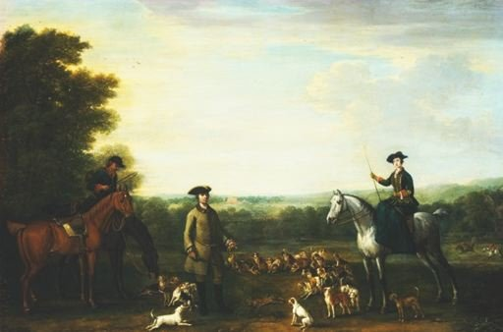
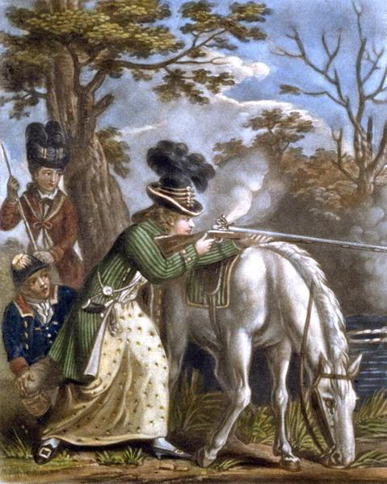

- Quote
- Edit
- Options

Hawkyns
- Curmudgeon With A Cannon
- Moderator

- 1,330 posts
- Gender:Male
- Location:New Haven Colony
- Interests:cannon, swords, cannon, wenches, cannon, muskets, cannon, pistols, cannon, re-enacting, cannon, rum, cannon, living history......... Did I mention cannon?
(IP: 76.225.187.66) · ·
Posted January 15, 2008 · Report post
Just to hark back to the beginning of this thread for a moment. My grandfather was born in Warwickshire at the beginning of the last century. The term 'wench' was still in use and meant nothing than an unmarried girl. he used it fairly regularly. I'm rather afraid the rennies have much muddied the waters concerning this.
Hawkyns

- Quote
- Edit
- Options

JoshuaRed
- Dread Pyrate
- Member

- 1,342 posts
(IP: 72.224.164.87) · ·
Posted January 16, 2008 · Report post
Quote
I'm rather afraid the rennies have much muddied the waters concerning this.
No one should be surprised by that...they're first class champs at that sort of thing!

- Quote
- Edit
- Options

Capt. Sterling
- Sticky Fingers Sterling Needs a New Hat
- Member

- 10,302 posts
- Gender:Pyrate Hunter
- Location:here
- Interests:Killing pirates, haven't met one yet worth keeping alive....
(IP: 65.160.148.76) · ·
Posted January 16, 2008 · Report post
Captain Pogue said:
I'm a bit confused, it may be from me using "hunting" a bit too much. She's getting a riding habit, which was used for travel as well as hunting, fashionable undress. Am I off on that?
Your remark about walking around port dressed in hunting attire concerns me that I've got some incorrect assumptions about a riding habit. Unless your thinking of something else other than a riding habit, or a riding habit with all of the hunting equipment. Please correct me if I'm wrong.
Pirates are able to walk around port with guns, is it my 21st century mentality that keeps getting in the way?
Hunting attire or traveling clothes are both correct for what we call a lady's riding habit... my concern is the long gun. For her to walk around port/town with such a garment is fine for traveling... I am just questioning the long gun. Why would she be hunting in town? Why would she be carrying it in town? Hunting, especially for a lady dressed in such a fashion, was pretty much a sport for the well to do...if she is going into town I think odds are she would bring along a servant for protection, and he might be armed. She could be armed as well, but with such an obvious weapon? As for hunting, once she was done hunting odds are she would pass that gun off to someone else to carry as well.
Remember hunting then is done for survival or for sport...those that need it to survive aren't wearing fancy silk gowns to hunt in...and odds are the men of the family are seeing to that task. For sport we are talking about them with the means to do so...not like in the US now a days.

- Quote
- Edit
- Options

Capt. Sterling
- Sticky Fingers Sterling Needs a New Hat
- Member

- 10,302 posts
- Gender:Pyrate Hunter
- Location:here
- Interests:Killing pirates, haven't met one yet worth keeping alive....
(IP: 65.160.148.76) · ·
Posted January 16, 2008 · Report post
I am sorry I am not making much sense as of late... my apologies

- Quote
- Edit
- Options

Captain Pogue
- Ship's Master
- Member

- 190 posts
- Location:Portland, Or
- Interests:All things Piratical.<br>Escaping Texas and moving up to the Northwest.<br>Making things.
(IP: 66.68.185.229) · ·
Posted January 16, 2008 · Report post
No worries Capt., your making sense. I'm just trying to get a good sense of women/firearms/ and the stuff related to hunting that women would carry. I understand what your saying about a woman carrying a gun. That was the age of the weaker sex and they'd probably have a servant tag along to do all of the carrying. Especially if they shot something. I'm just trying to dig deeper and get as much as I can out of the topic of the thread. I'd love to make a hunting bag that would befit a lady, just need ot know what they looked like
I was thinking more of along the lines of travelling thru port or aboard a ship, carrying a gun would be for protection. Beinging a lady a fowling piece seemed natural, if she enjoyed hunting. Due to circumstances not being able to bring a trusted servant...
Pogue

- Quote
- Edit
- Options

Lady Alyx
- Dread Pyrate
- Member

- 1,221 posts
(IP: 128.152.20.33) · ·
Posted January 16, 2008 (edited) · Report post
Michael, what do you want all these things for, I mean to carry all this unnecessary stuff around for reenactment is kind of strange. Do you want these items for the house or when you go to reactments or faires?
I am surprised not more women have answered this posting. Wenches are usually from the lower class working ranks like barmaids. I am sure more pirates were with barmaids than upper class women, unless they had plenty of money and were a handsome rogue.
A couple of things women had that I know you can add to her wardrobe for practical use is a small hand mirror and some kind of cologne scented handkerchief or pomander, due to the streets smelled so.
This website had a really cool listing to go through
Glosarry of 18th century
Edited January 16, 2008 by Lady Alyx

- Quote
- Edit
- Options

michaelsbagley
- Smells Like Wet Sheep
- Moderator

- 2,548 posts
- Gender:Male
- Location:Columbus, Ohio
- Interests:Mostly into GAoP, but starting to develop more Buccaneer era stuff for re-enacting as well. Generally I do re-enact both piratical/nautical and other impressions from the period. I am focusing on more "common" impressions from the period (i.e. average sailor/pirate, rank and file Red Coat, early Colonial huntsman, etc.)
(IP: 69.219.80.75) · ·
Posted January 16, 2008 · Report post
Lady Alyx said:
Michael, what do you want all these things for, I mean to carry all this unnecessary stuff around for reenactment is kind of strange. Do you want these items for the house or when you go to reactments or faires?h
Lady Alex,
I don't particularily want any of these things... I was asking on behalf of my other half... Who has since logged in and started posting for herself... Knowing the people here a bity better than she does and hopefully having more of an idea of how to approach certain questions, I have still tried to add focus to this thread on behalf of my girlfriend here and there where I could...
Now as to carrying these things to re-enactments. I have stated in a previous post that the intention is NOT to carry all of these things to every re-enactment. There are many different style of re-enactments, for a re-enactment display at a local function, having LOTS of trinkets and period do-dads can make for a more interesting display. For a long road trip to a longer re-enactment that involves camping, going minimal is as Sterling suggested the best idea (I know this from personal experience as well). And of course bringing any of these do-dads to a faire or festival where we would be walking around all day, would just be rediculous.
And yeah, I do like having strange and odd re-enactment do-dads as home decor items. If only I can get Jessica to agree with my decor sense more... Just kidding.

- Quote
- Edit
- Options

Lady Alyx
- Dread Pyrate
- Member

- 1,221 posts
(IP: 128.152.20.33) · ·
Posted January 17, 2008 · Report post
No problem, was just wondering, now it makes sense!!!! Good luck on yer treasure hunt of finding things! The other day I had a search on tricorns..and the cutest vintage from the 1800's or so a tricorn pin holder (it seemed just for straight pins) and it folded flat but could fold out into a tricorn. (the pins were kept in the center of the hat)..was the cutest thing. If I find that pic I will post it here.

- Quote
- Edit
- Options

Mary Diamond
- It's My Fault
- Moderator

- 1,050 posts
- Gender:Female
- Location:Illinois
- Interests:Things I Love: Horticulture, Travel, Volleyball, Reading, Sewing, Costuming, Halloween, esp. props!, Halo, Halo2, Halo3, ODST, and, of course, Pyracy.
(IP: 67.167.49.211) · ·
Posted January 17, 2008 (edited) · Report post
Speaking from my personal experience ~
When the scenario calls for it, I carry 2 Queen Anne Pistols, a sword, and a cartridge box (which I believe you are calling a hunting bag?) on a belt. In addition to the riding habit, it feels like carrying an additional 20 pounds around your waist. And that is not even considering the items in my pockets! (Camera, handkerchief, lip balm, doubloons, mini-wallet, phone).
After 8 hours at PiP in my wool riding habit, with pistols & cartridge box, wearing sensible buckle shoes, my back was begging for mercy. That being said, I never had to worry as to where I was going to set my guns down (both being secure in my belt). A fowler will constantly keep at least one hand occupied, and it easily knocked over when set down. (I personally prefer both hands free to drink and shop at will.)
I would advise Ilanah to first wear the many layers of a riding habit, before attempting to carry around a large and awkward firearm, which can weigh 6 pounds or more. Also, keep in mind that the riding habit was a common travel outfit, so it would not be necessary to carry a gun at all times. And, for purposes of self-preservation in town, I could hardly think of a less cumbersome item for a woman to aim in a quick fight. It would be easier to use it as a club!
Embroidery featured quite highly in a ladies wardrobe ~ as purses were not used commonly, a pair of lovely embroidered linen pockets under a ladies petticoats were actually one of the things counted amongst "A Ladies Things". A few common embroidered items ~
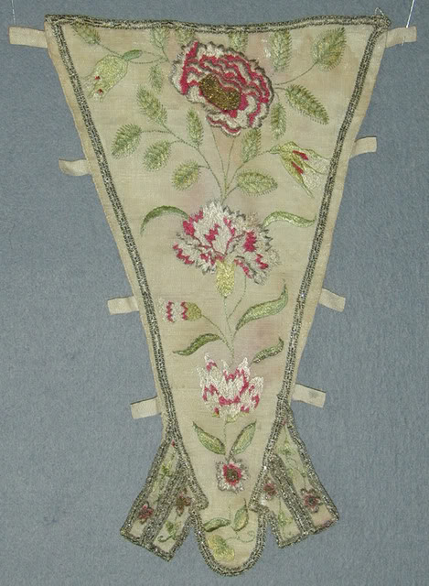Embroidered stomacher 1720-40
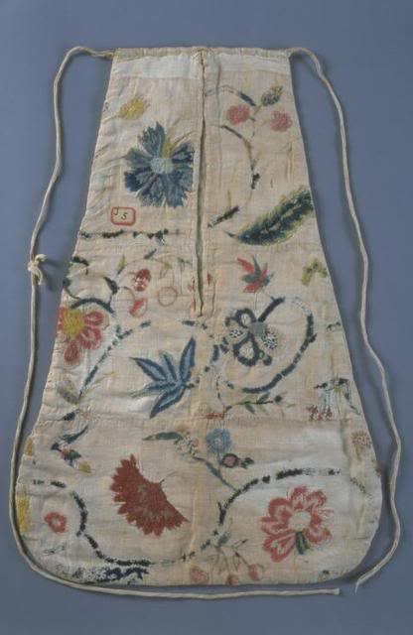Embroidered pockets 1760-80
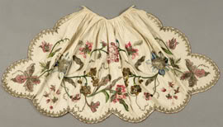Embroidered apron 1740
Edited January 17, 2008 by Mary Diamond

- Quote
- Edit
- Options

Salty
- Dread Pyrate
- Member

- 1,012 posts
- Location:back in the mountains of westren pa...good to be back home
- Interests:maker o pots, tankards, and rum jugs. the natural world as it be and history that was not written by the winners.
(IP: 205.149.72.8) · ·
Posted February 7, 2008 · Report post
^lovely pics
for those of us not playing the grand lady and or doubling as a lad when the fighting gets fun, errrrr heavy, is there a way to make accesories that will handle both personas?

- Quote
- Edit
- Options

Mary Diamond
- It's My Fault
- Moderator

- 1,050 posts
- Gender:Female
- Location:Illinois
- Interests:Things I Love: Horticulture, Travel, Volleyball, Reading, Sewing, Costuming, Halloween, esp. props!, Halo, Halo2, Halo3, ODST, and, of course, Pyracy.
(IP: 67.167.49.211) · ·
Posted February 11, 2008 · Report post
Embroidery was to show off the skill of a lady of means, who would have had the time to invest in such elaborate items. A more common lady would have been hard pressed to find the time for such detail, but would still have owned linen pockets, stomacher and apron.
Items that would work interchangeably for a lad and a lady ~ well, that gets a bit more difficult. Off the top of my head, I think of eating utensils, plate and mug. A folding knife. Linen handkerchief. Possibly writing items and a pocket watch, though that really depends on the status of the characters you would play.
Don't forget ~ ladies can be involved in fights As Ladies! Bess and I fight each other ~ she with her giant spoon, me with my smallsword. Funny, she always wins! Maybe it is because I can't cook... and don't recognize the thing coming at my head. The more ladies that participate as ladies, the easier this becomes.

- Quote
- Edit
- Options

Kate_Souris
- Texting on a Stolen Bike
- Member

- 545 posts
- Gender:Female
- Location:Ohio
(IP: 69.218.229.139) · ·
Posted March 6, 2008 · Report post
It's taken me a while to get this posted up here...but at RF4, we got some 'ladys things'. Michael bought me a small hand mirror and a cobalt blue inkwell and a prayer book. I also got my writing set as well.
I collect 'stuff', not necessarily to carry it all around, but for the set up of it, if that makes sense. Really....I don't carry all that much on my person when I am at an event, so I think we are doing well with the stuff gathering.
If any one has any other ideas, please let me know! :)

- Quote
- Edit
- Options

Cheeky Actress
- Contesse de Tosspot
- Member

- 3,876 posts
- Gender:Female
- Location:Middlesort Port of the Midwest
- Interests:Seeking all who have been Forsaken in their quest.
(IP: 141.129.1.98) · ·
Posted March 10, 2008 · Report post
Kate,
You may want to consider other items related to your faith.
Other than the bible, you may want to consider a period rosary...(depending on your faith, of course).
I do have such an item for sale. I can email you a photo of it if you were to PM me. Thank you.

LadyBarbossa
- Wealth Redistributor & Mischief Making
- Moderator

- 4,641 posts
- Gender:Female
- Location:The Land Between Two Rivers, aka Iowa
- Interests:18th c Piracy to American Revolution, Victorian Thespians, Equitation, tigers, Friesians, cooking, playing my viola & music in general. Researcher of Major General Baron Johann de Kalb. LOVES the Phantom of the Opera (who's also Brethren)! Transformers, Stargate, Star Trek, Star Wars, NCIS, Bones, The X Files
(IP: 205.188.116.16) · ·
Posted March 10, 2008 · Report post
Very wicked, Kate.
Aye, I take with me to events what I think I may need. Most of the time I actually use three-fourths of my stuff - sewing items, cooking items, writing items.
But, depending upon what you will do, you may or may not use what you bring.
I have heard and even seen some images of women wearing breeches. Some wore them under a petticoat.
Hard to say really what to recommend. It highly depends upon who you are portraying.
And I'll agree with what everyone has said thus far. :::points above:::
Not sure what other items would be unisex and piratey.
Most of my stuff that is not piratey is Rev War era and very much a Gentlewoman's stuff.
~Lady B

- Quote
- Edit
- Options

Capt. Sterling
- Sticky Fingers Sterling Needs a New Hat
- Member

- 10,302 posts
- Gender:Pyrate Hunter
- Location:here
- Interests:Killing pirates, haven't met one yet worth keeping alive....
(IP: 76.1.131.180) · ·
Posted March 11, 2008 · Report post
Saltypots said:
^lovely pics
for those of us not playing the grand lady and or doubling as a lad when the fighting gets fun, errrrr heavy, is there a way to make accesories that will handle both personas?
If you can the best thing is to keep it simple... the more accessories, the more stuff you need to drag along... the bigger vehicle you need... trust me...keep it simple.

- Quote
- Edit
- Options

Kate_Souris
- Texting on a Stolen Bike
- Member

- 545 posts
- Gender:Female
- Location:Ohio
(IP: 99.168.74.201) · ·
Posted March 11, 2008 · Report post
Cheeky Actress said:
Kate,
You may want to consider other items related to your faith.
Other than the bible, you may want to consider a period rosary...(depending on your faith, of course).
I do have such an item for sale. I can email you a photo of it if you were to PM me. Thank you.
I have one, Miss Cheeky, but thank you for the offer. A lovely lapis and silver one.

- Quote
- Edit
- Options

Cheeky Actress
- Contesse de Tosspot
- Member

- 3,876 posts
- Gender:Female
- Location:Middlesort Port of the Midwest
- Interests:Seeking all who have been Forsaken in their quest.
(IP: 207.67.93.220) · ·
Posted March 12, 2008 · Report post
Kate...it sounds lovely and I would love to see it too!
Silver is always a nice choice!
Captain Sterling, didn't Silver stand for purity? I think it still does these days.

- Quote
- Edit
- Options

LadyBarbossa
- Wealth Redistributor & Mischief Making
- Moderator

- 4,641 posts
- Gender:Female
- Location:The Land Between Two Rivers, aka Iowa
- Interests:18th c Piracy to American Revolution, Victorian Thespians, Equitation, tigers, Friesians, cooking, playing my viola & music in general. Researcher of Major General Baron Johann de Kalb. LOVES the Phantom of the Opera (who's also Brethren)! Transformers, Stargate, Star Trek, Star Wars, NCIS, Bones, The X Files
(IP: 205.188.116.16) · ·
Posted March 12, 2008 · Report post
Not sure what other meaning silver had.
I know in the Bible, gold stood for "Deity", silver stood for "Death" and brass stood for "resurrection" or "rebirth". At least it did in the old Testiment. Hence why you will see me wearing more silver and brass.
Simple? :::Looks at Sterling oddly::: I'll only carry upon my person what I deem necessary (sword, pistol, coinage, and attire). Other than that, everything else remains at the camp (or on ship if I had one), and that would be A LOT of stuff!
~Lady B

- Quote
- Edit
- Options

Capt. Sterling
- Sticky Fingers Sterling Needs a New Hat
- Member

- 10,302 posts
- Gender:Pyrate Hunter
- Location:here
- Interests:Killing pirates, haven't met one yet worth keeping alive....
(IP: 76.1.129.146) · ·
Posted March 12, 2008 · Report post
Sorry only know what Sterling stands for...

- Quote
- Edit
- Options

LadyBarbossa
- Wealth Redistributor & Mischief Making
- Moderator

- 4,641 posts
- Gender:Female
- Location:The Land Between Two Rivers, aka Iowa
- Interests:18th c Piracy to American Revolution, Victorian Thespians, Equitation, tigers, Friesians, cooking, playing my viola & music in general. Researcher of Major General Baron Johann de Kalb. LOVES the Phantom of the Opera (who's also Brethren)! Transformers, Stargate, Star Trek, Star Wars, NCIS, Bones, The X Files
(IP: 205.188.116.16) · ·
Posted March 12, 2008 · Report post
I'll plead th' right t' remain silent in r'sponse t' that.
~Lady B

- Quote
- Edit
- Options

Capt. Sterling
- Sticky Fingers Sterling Needs a New Hat
- Member

- 10,302 posts
- Gender:Pyrate Hunter
- Location:here
- Interests:Killing pirates, haven't met one yet worth keeping alive....
(IP: 76.1.129.146) · ·
Posted March 12, 2008 · Report post
Actually it stands for "adhering to the highest standards."... like the best clothes, the best weapons, the best crew, the best mistress...

- Quote
- Edit
- Options

Kate_Souris
- Texting on a Stolen Bike
- Member

- 545 posts
- Gender:Female
- Location:Ohio
(IP: 99.231.192.148) · ·
Posted March 15, 2008 (edited) · Report post
Went to the Royal Ontario Museum today...great section with lots of goodies from the period...
1.) Tea caddy with paper quill work
2.) Toothpick box with combined toothpick/ear cleaner
3.) Portait Miniature-enamel painted on copper.
4.) Etui- Container of tools for needlework and personal needs. Tweezers, scissors, folding ruler, knife, and ivory writing tablet (for use with a pencil and it wipes off)
All of these were dated 1700's. :)
Edited March 15, 2008 by Kate_Souris

- Quote
- Edit
- Options

Mary Diamond
- It's My Fault
- Moderator

- 1,050 posts
- Gender:Female
- Location:Illinois
- Interests:Things I Love: Horticulture, Travel, Volleyball, Reading, Sewing, Costuming, Halloween, esp. props!, Halo, Halo2, Halo3, ODST, and, of course, Pyracy.
(IP: 67.167.49.211) · ·
Posted March 15, 2008 · Report post
Lovely items! Was that first quarter 1700s? If so, fantastic!

